ONEWAY PREC BY HOS
/STATISTICS DESCRIPTIVES HOMOGENEITY WELCH
/PLOT MEANS
/MISSING ANALYSIS.

Oneway

Notes
Output Created |  | 05-May-2019 23:42:43
Comments
Input | Active Dataset | DataSet0
Input | Filter | <none>
Input | Weight | <none>
Input | Split File | <none>
Input | N of Rows in Working Data File | 30
Missing Value Handling | Definition of Missing | User-defined missing values are treated as missing.
Missing Value Handling | Cases Used | Statistics for each analysis are based on cases with no missing data for any variable in the analysis.
Syntax |  | ONEWAY PREC BY HOS  /STATISTICS DESCRIPTIVES HOMOGENEITY WELCH  /PLOT MEANS  /MISSING ANALYSIS.
Resources | Processor Time | 00 00:00:00.156
Resources | Elapsed Time | 00 00:00:00.160

[DataSet0]

Descriptives
PREC
 | N | Mean | Std. Deviation | Std. Error
Between 7-5 hours of sleep | 8 | 36.8750 | 33.37423 | 11.79957
Between 7-9 hours of sleep | 8 | 44.3750 | 40.12814 | 14.18744
Less than 5 hours of sleep | 7 | 51.4286 | 42.00340 | 15.87579
More than 9 hours of sleep | 7 | 46.4286 | 36.48222 | 13.78898
Total | 30 | 44.5000 | 36.42067 | 6.64947

Descriptives
PREC
 | 95% Confidence Interval for Mean |  | Minimum | Maximum
 | Lower Bound | Upper Bound | Minimum | Maximum
Between 7-5 hours of sleep | 8.9734 | 64.7766 | .00 | 95.00
Between 7-9 hours of sleep | 10.8270 | 77.9230 | 10.00 | 130.00
Less than 5 hours of sleep | 12.5819 | 90.2752 | 5.00 | 125.00
More than 9 hours of sleep | 12.6881 | 80.1690 | 5.00 | 120.00
Total | 30.9003 | 58.0997 | .00 | 130.00

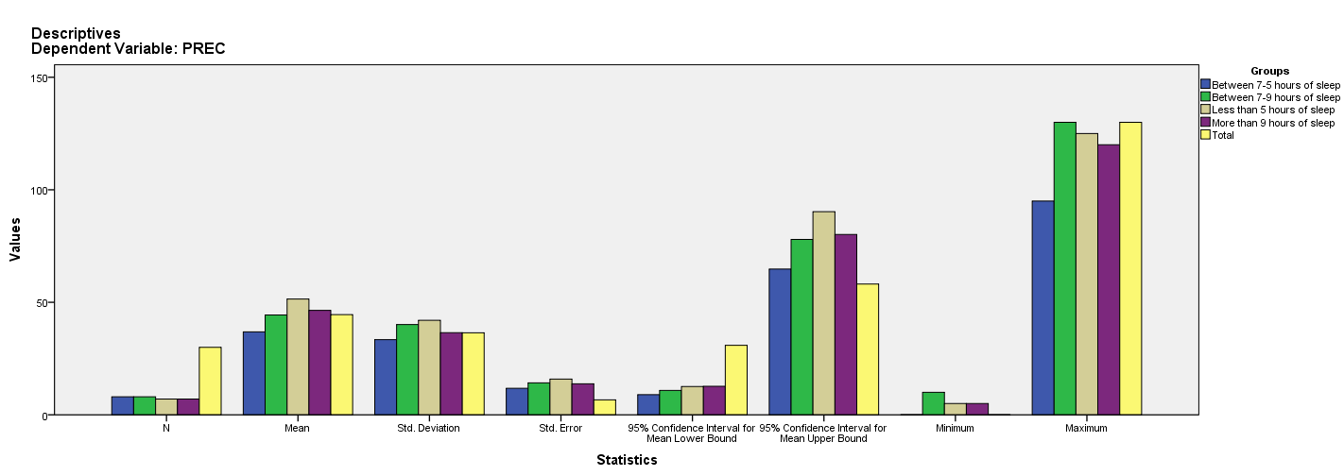

Test of Homogeneity of Variances
PREC
Levene Statistic | df1 | df2 | Sig.
.108 | 3 | 26 | .954

ANOVA
PREC
 | Sum of Squares | df | Mean Square | F | Sig.
Between Groups | 827.321 | 3 | 275.774 | .190 | .902
Within Groups | 37640.179 | 26 | 1447.699
Total | 38467.500 | 29

Robust Tests of Equality of Means
PREC
 | Statisticª | df1 | df2 | Sig.
Welch | .187 | 3 | 14.186 | .904
a. Asymptotically F distributed.

Means Plots

